Pakistan J. Zool., vol. 43(3), pp. 549-554, 2011.

A Revision of Myrocheine Genus Ennius Stål With Special Reference to Redescription of E. monteironis Distant (Hemiptera: Pentatomidae: Pentatominae) and Their Phylogenetic Relationships*

Muhammad Zahid,¹* and Imtiaz Ahmad²
¹Department of Zoology, Federal Urdu University of Arts, Science and Technology, Gulshan-e-Iqbal Campus, Karachi, Pakistan.
²Dr. Afzal Hussain Qadri Biological Research Center, University of Karachi, Karachi-75270, Pakistan

Abstract.- The myrocheine stink bug genus Ennius Stål with its species Ennius monteironis Distant is redescribed with special reference to its metathoracic scent auricle and male genitalia including inflated aedeagus and a key to all the species of the genus Ennius and in this light the phylogenetic relationships of Ennius within its tribe Myrocheini Stål are also briefly discussed.

Keywords: Myrocheini, Pentatomidae, Pentatominae, Ennius spp.

INTRODUCTION

The stink bug genus Ennius was described by Stål (1861) under his tribe Myrocheini to accommodate the species Scicoris ater Dallas (1851) which became its type species by original designation. Ahmad and Zahid (2007) described a new species of Ennius Stål i.e. E. neomorio from Nigeria, with special reference to its metathoracic scent auricle and male genitalia. Linnavuori (1982) gave a key to ater Dallas, longulus Germar, monteironis Distant and morio Dallas with partial description of Ennius and giving some illustrations of the above species but he did not completely describe anyone of them. To fill these gaps presently we give here a key to all the known species of the genus and redescribe E. monteironis with special reference to characters of metathoracic scent auricle and male genitalia and in this light the phylogenetic relationships of the genus Ennius with in its tribe Myrocheini are also briefly discussed.

MATERIALS AND METHODS

Authentically determined and undetermined specimens of Ennius Stål were examined, some dissected and borrowed (for description and for
_______________________
* Part of the Ph. D. thesis of first author.
** Corresponding author: iahmad3141@yahoo.com
0030-9923/2011/0003-0549 $ 8.00/0
Copyright 2011 Zoological Society of Pakistan.
taking photograph) by the courtesy of Mr. MickWebb, Incharge Hemiptera Section, Department of Entomology and the authorities of Natural History Museum London (BMNH), during the visit of the second author in July 2005 to that museum. For inflation of aedeagus we followed the technique of Ahmad (1986) and Ahmad and McPherson (1990, 1998). After removing the label the pinned dry specimen was plunged into boiling water in a beaker for 3-5 minutes. When the specimen got softened it was slipped off the pin and its pygophore was removed under a binocular microscope. The pygophore was boiled in 10% KOH at 40-45⁰C for 10 minutes. The pygophore was transferred in a cavity block and was washed thoroughly. The fine watch maker forceps (no. 5 or finer) were used for the inflation of the aedeagus. After the aedeagus was fully inflated illustrations of pygophore, paramere and inflated aedeagus were made in different views and then the components of the genitalia were transferred into a microvial with a drop of glycerine and pinned with the insect. For the measurements of the parts and description generally the techniques of Ahmad and Afzal (1989) were followed. Various taxonomic characters were compared in duplicate specimens including those of genitalia and were found remarkably consistent. The specimen examined under E. monteironis appears to be a representative specimen of the species. All the measurements are in millimeters and all the photographs were taken using Nikon binocular stereomicroscope SMZ800.
RESULTS

Genus ENNIUS Stål

Ennius Stål 1861: 199; 1876: 52, 53; Lethierry and Severin, 1893: 110; Kirkaldy, 1909: 206; Gillon, 1972: 322; Gross, 1975: 220; Linnavuori, 1982: 68, 72.
Paramecocoris (Ennius) Stål, 1865: 112.

Body of moderate size (8.5 mm -11.4 mm); elongated; generally brown with dark brown punctures; head usually broader than long; paraclypei longer than clypeus and enclosing the clypeus; antennae with basal segment equal or shorter than head apex, second antennal segment longer or slightly longer than third but shorter than fourth; labium reaching or passing beyond middle coxae; pronotum with lateral margin slightly convex, anterior angles slightly toothed or rounded, humeral angles rounded or subrounded; scutellum long and rounded or subrounded at apex; metathoracic scent ostioles small with large peritreme.

Male genitalia
Pygophore as broad as long, quadrangular, lateral lobe prominent and rounded, dorsomedian surface concave or deeply concave, ventromedian surface slightly notched; paramere somewhat F-shaped with curved blade; aedeagus with large conjunctival appendages.

Female genitalia
Posterior margin of first gonocoxae convex; ninth paratergites small but not reaching medially fused posterior margin of eighth paratergites.

Comparative note
This genus appears to form a subclade with Myrochea Amyot and Serville, Dorpius Distant, Stysicoris Ahmad and Kamaluddin and Munshiana Ahmad and Kamaluddin with apomorphies in having antennae with second segment distinctly longer than third in length. It however appears entirely isolated in its subclade in having second antennal segment only slightly longer than third and metathoracic scent complex with peritreme long and anteriorly curved.

Distribution
Ethiopian region.

Type species
Sciocoris ater Dallas 1851.

KEY TO THE SPECIES OF THE GENUS ENNIUS STÅL

1. Entirely black, lateral lobes of pygophore in ventral view round, not projected posteriad, ventroposterior margin smoothly concave, medially very slightly constricted E. ater (Dallas)
- More colourful, at least lateral margins of pronotum with narrow and broad ring in middle and hind tibiae pale, lateral lobes of pygophore in ventral view not round as above, ventroposterior margin not smoothly concave as above, medially not constricted 2
2. Lateral margins of pronotum straight, lateral lobes of pygophore in ventral view prominent, hump like, anteriorly directed, ventro-posterior margin strongly sinuate, medially notched, U-shaped, head and membrane of hemelytra in male black, rest of the body above pale ochraceous E. neomorio Ahmad and Zahid
- Lateral margins of pronotum slightly sinuate, convex or markedly curvate, lateral lobes of pygophore in ventral view not hump like, ventroposterior margin not strongly sinuate, medially not notched, colouration not as above
3
3. Lateral margins of pronotum sinuate, lateral margins of head less strongly converging apically, scutellum longer, about 1.42-1.53 x as long as broad, lateral lobes of pygophore in ventral view very slightly projected posteriad, apices conical, ventroposterior margin medially V-shaped, posteromedian lobes on either side dorsally prominent, also clearly visible in lateral aspect
E. morio (Dallas)
- Lateral margins of pronotum curvate or strongly so, lateral margins of head, strongly converging apically from base, scutellum shorter 1.33 x as long as broad, lateral margins of pygophore medially in ventral view constricted, apically much broader, median lobes on either, side apically much smaller, not prominent laterally 4
4. Larger species, more than 11.0 mm in length lateral margins of pronotum much prominently curvate and narrowly lamellate, sides of venter strongly coarsely punctate E. longulus (Germar)
- Small species, much less than 11.0 mm in length lateral margins of pronotum curvate but not prominently as above, sides broadly lamellate, sides of venter coarsely punctate but not as strongly as above
E. monteironis Distant
Ennius monteironis Distant
(Figs. 1A-G)

Ennius monteironis Distant 1892: 188; Letheiry and Severin, 1893: 110.
Ennius monteironis: Distant, 1898: 296; Kirkaldy, 1909: 206; Schouteden, 1913: 194; Linnavuori, 1982: 72, 93.
Ennius frater: Linnavouri, 1975: 31.

Colouration and general shape
Body (Fig. 1A) brown with dark brownish punctures, head anteriorly blackish; eyes brownish; ocelli pinkish; membrane of hemelytra brown; body narrowly elongated.

Head
Head as broad as long, anteocular distance slightly longer than remainder of head; paraclypei longer than clypeus and enclosing the latter, lateral margins slightly sinuate, paraclypeal lobe angulate in front of eyes, apex of paraclypei rounded; antennae with basal segment shorter than head apex, third to fifth antennal segments mutilated, length of segments I 0.5, II 1.0, III to V mutilated; labium passing beyond mesocoxae, second and third equal in length, first shortest, length of labial segments I 0.8, II 1.1, III 1.1, IV 0.9; anteocular distance 1.1, remainder of head 0.8; width of head 0.8; interocular distance 1.5; interocellar distance 0.8.

Thorax
Pronotum about 2 x broader than its length, anterior margin slightly broader than head width, anterior angles slightly toothed, lateral margins convex, humeral angles rounded, length of pronotum 2.1, width 4.4; scutellum long with apex subrounded, length of scutellum 4.0, width 2.8; metathoracic scent gland ostiole (Fig. 1B) slit like with distinct peritreme; distance base scutellum-apex clavus 3.1, apex clavus-apex corium 1.7; apex corium-apex abdomen including membrane 1.6; apex scutellum-apex abdomen including membrane 2.4.

Abdomen
Convex beneath, connexiva slightly exposed at repose, abdomen shorter than membrane of hemelytra; total length 10.4.

Male genitalia
Pygophore (Fig. 1C) as broad as long, quadrangular, lateral lobe rounded, dorsomedially notched; paramere (Fig. 1D) F-shaped, outer margin of blade convex, apex of blade rounded; aedeagus (Figs. 1E-1G) having theca with finger like lateral thecal appendage, dorsal membranous conjunctival appendage with horn like sclerotized plate at apex, penial lobes with dilated apex.

Material examined
One male, South Africa: “pinatown B.M. 1926” lodged at BMNH. London.

Comparative note
This species is most closely related to E. longulus in having lateral margins of pronotum curvate or strongly so, lateral margins of head strongly converging apicad from base and scutellum shorter 1.33 x projecting posteriad with apex conical but it can easily be separated from the same latter being larger species, lateral margins of pronotum of much prominently curvate and narrowly lamellate and sides of venter strongly coarsely punctate.

DISCUSSION

Ennius falls in the subclade (Fig. 2) of Myrochea Stål, the type genus of the tribe Myrocheini Stål with the genera Kyrtalus Van Duzee, Neococalus Bergroth, Humria Linnavuori, Erachtheus Stål, Dellegorguella Spinola, Ennius, Munshiana Ahmad and Kamaluddin, Stysicoris Ahmad and Kamaluddin, Dorpius Distant and Myrochea with clearcut synapomorphies i. e., body elongate and paraclypei much longer than clypeus and enclosing it infront which clearly separate it from its sister group subclade. Laprius Stål with several Australian, western and eastern Palaearctic with only Dissocolpus Bergroth,and Pretorius Distant in the Ethiopian region with other representatives distributed in the Indo-pakistani, Indo-burmese and Indo-chinese region (Zahid, 2006; Zahid and Ahmad, 2009 ). In contrast to this sister group subclade of Laprius Stål which is predominantly Palaearctic, Oriental and Australian in distribution, the present Myrochea subclade
to which present genus Ennius belongs is

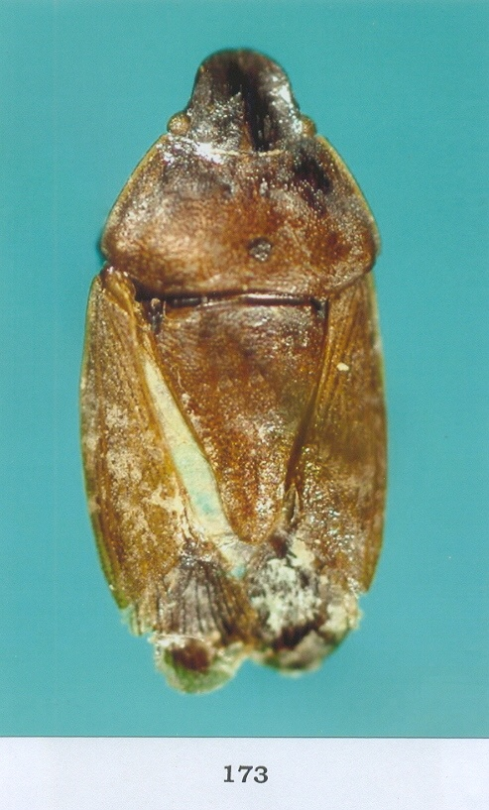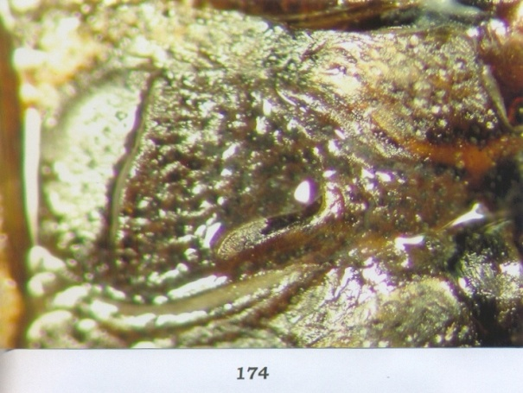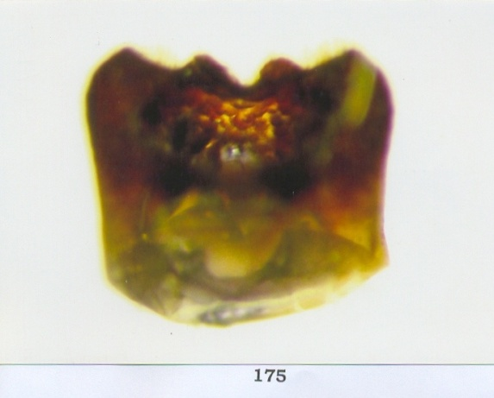
1.0mm A 1.0mm B 0.65 mm C
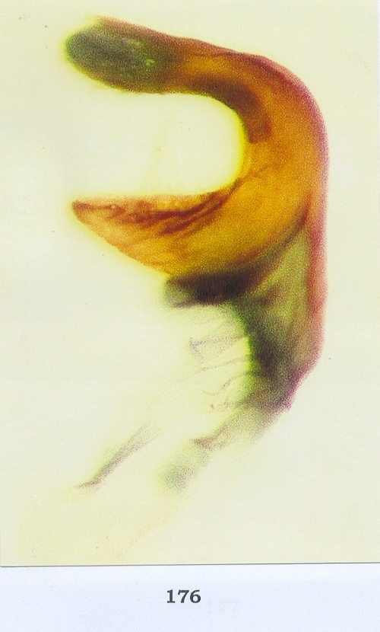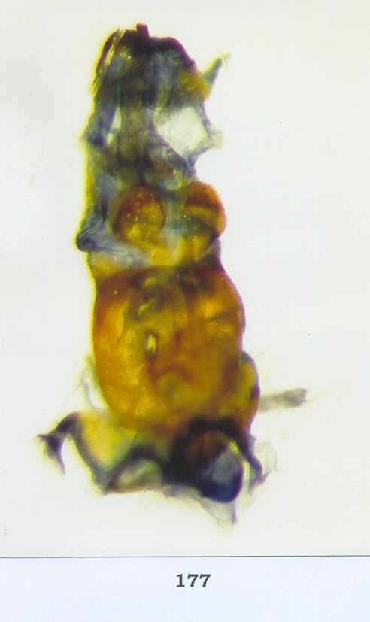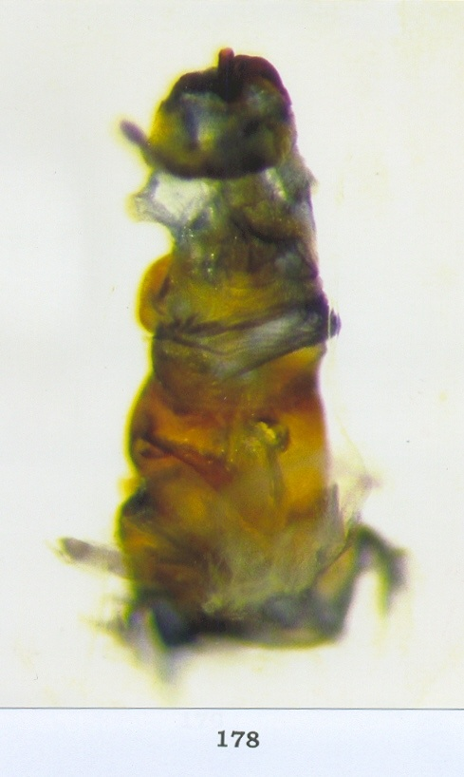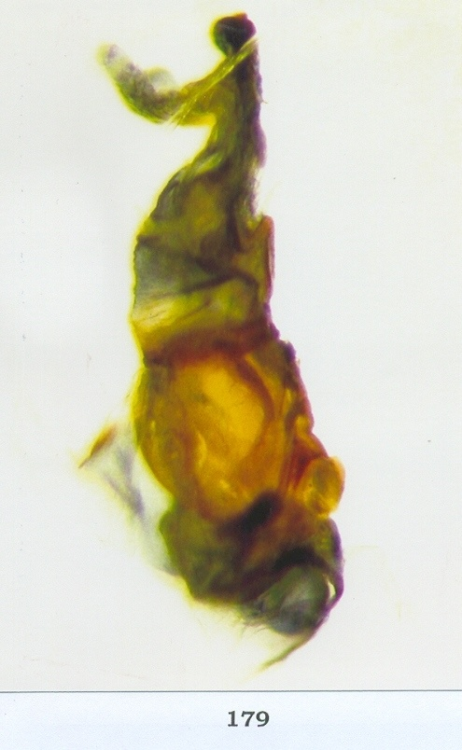
D E F G
0.65 mm

Fig. 1. Ennius monteironis: A, dorsal view; B, metathoracic scent auricle, ventral view; C, pygophore, dorsal view; D, paramere, inner view; E, inflated aedeagus, dorsal view; F, same, ventral view; G, same, lateral view.

predominantly Ethiopian in distribution with Neococalus, Humria, Erachtheus, Delegorgoella, Ennius and Stysicoris entirely Ethiopian in distribution and Dorpius and Myrochea largely Ethiopian in distribution with only Dollingiana, Kyrtalus and Munshiana being entirely Oriental in distribution and only a monotypic small genus Kyrtalus extending its distribution range to Thailand in the east of oriental region.
Kyrtalus although shares the synapomorphies of its subclade as noted above in having body elongated and paraclypei much longer than clypeus and enclosing it infront but its autapomorphies i.e., head and pronotum much expanded and regularly arcuate and planate, scutellum long and narrowed at apex and labium much reduced not reaching even to mesocoxae, its more or less obovate body and its endemic distribution in eastern oriental region isolate it in its entire subclade. Neococalus, Humria, Erachtheus and Delegorgoella, Stysicoris, Myrochea, Dorpius and Munshiana (only this genus appears entirely endemic to lower Sindh, Pakistan) and Dorpius (with only type species Dorpius cribrosus (Klug) is distributed in Ethiopian region). Probably through Dorpius this subclade has extended from Ethiopian to extreme east of oriental probably eastern palaearctic region.Recently Ahmad and Zahid (2007) have confirmed the earlier stand of Qadri (1968) that the coastal areas of Southern Sindh and Makran (Balochistan, Pakistan) have indeed Ethiopian influence. So Munshiana and Dorpius probably have this influence.

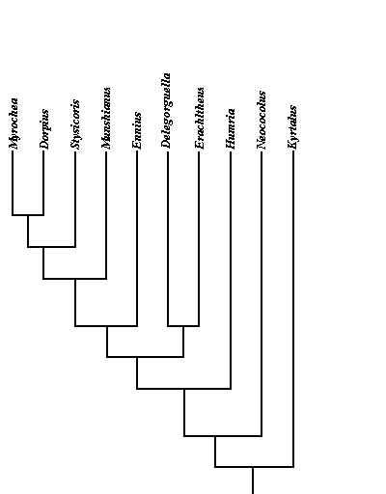

Fig. 2. Cladogram showing phylogenetic relationship of Ennius with related genera.

In this clade Kyrtalus appears to be entirely isolated from the rest of the clade which as noted above has Ethiopian influence. Van Duzee (1929) described it to accommodate an Oriental species mackiei Van Duzee. This taxon although shares synapomorphy such as paraclypei much longer than clypeus and enclosing it but it appears entirely isolated in the Ethiopian clade as noted above with the autapomorphies of head more expanded and regularly arcuate before the smaller clypeus, the antennae and labium are much shorter, the metathoracic scent gland ostiolar complex with ostiolar canal much longer and the upper surface of the body is more coarsely punctate and therefore Kyrtalus appears to play an out group relationship with the rest of this Ethiopian subclade.
Neococalus also appears to play out group relationship with the rest of Ethiopian clade with autapomorphies such as apex of paraclypei acute and paramere simple I-shaped with broad apex. Humria in the same way appears entirely isolated in this clade and plays an out group relationship with the rest of the clade comprising Erachtheus, Delegorguella, Ennius, Munshiana, Stysicoris, Dorpius and Myrochea with autapomorphies such as paramere T-shaped. This clade appears to be bound together with synapomorphies such as paraclypei much longer and enclosing clypeus infront. In this clade Erachtheus and Delegorguella appear to be most closely related playing sister group relationship with each other and out group relationship with rest of the clade on the basis of synapomorphies such as second antennal segment longer than third in length. The rest of this clade appears to be neatly held together by the synapomorphies such as basal antennal segment shorter than head apex but not reaching 1/2 of paraclypei and paramere F-shpaed. In this clade Ennius again appears entirely isolated with autapomorphies such as second antennal segment slightly longer than third. The rest of the clade represented by Munshiana, Stysicoris, Dorpius and Myrochea is held together neatly by the synapomorphies such as second antennal segment more than 1.5x longer than third. In this clade Munshiana which is at present the only genus represented in the areas of Southern Sindh having certainly Ethiopian influence as noted above appears entirely isolated with the autapomorphies such as anterior angles of pronotum spinose.

REFERENCES

AHMAD, I., 1986. A fool-prooftechnique for inflation of male genitalia in Hemiptera (Insecta). J. ent. Soc. Kar., 1: 111-112.
AHMAD, I. AND AFZAL, M., 1989. A revision of Myrocheini (Pentatomidae: Pentatominae) from Indo-Pakistan area. Orient Insects, 23: 243-267.
AHMAD, I. AND MCPHERSON, J., 1990. Male genitalia of the type species of Corimelaena White, Cydnoides Malloch and Galgupha Amyot and Serville (Hemiptera: Cydnidae: Coriomalaeninae) and their bearing on classification. Ann. ent. Soc. Am., 83: 162- 170.
AHMAD, I. AND MCPHERSON, J.E., 1998. Additional information on male and female genitalia of Parabrochymena Lariviere and Brochymena Amyot and Serville (Hemiptera: Pentatomidae). Ann. ent. Soc. Am., 91: 800-807.
AHMAD, I. AND ZAHID, M., 2007. A New Species of Myrocheine genus Ennius Stål (Pentatomidae: Pentatominae) from Nigeria with Reference to its Male Genitalia and its Phylogenetic Relationships. Pakistan J. Zool., 39: 327-331.
DALLAS, W.S., 1851. List of the specimens of hemipterous insects in the collection of the British Museum. Part 1. Trustees of the British Museum, London, pp. 1-368, pls. 1-11.
DISTANT, W.L., 1892. Notes on Ethiopian Rhynchota. Ent. Month. Mag., 3:187-189.
DISTANT, W.L., 1898. Rhynchota from the Transvaal, Mashonaland, and British Nyasaland. Annals Mag. Nat. Hist., 2: 294-316.
GILLON, D., 1972. Les HémiptPres Pentatomides d'une savane préforestiPre de Côte-d'Ivoire. Ann. Univ. Abidjan, 5: 265-371.
GROSS, G.F., 1975. Handbook of the flora and fauna of South Australia. Plant-feeding and other bugs (Hemiptera) of South Australia. Heteroptera - Part 1. Handbooks Committee, South Australian Government, Adelaide, pp. 250.
KIRKALDY, G.W., 1909. Catalogue of the Hemiptera (Heteroptera) with biological and anatomical references, lists of foodplants and parasites, etc. Vol. I. Cimicidae. Berlin. pp. 392.
LETHIERRY, L. AND SEVERIN, G., 1893. Catalogue général des HémiptPres. Pentatomidae, Bruxelles, 1: pp. 286.
LINNAVUORI, R., 1975. Hemiptera Heteroptera of the Sudan with remarks on some species of the adjacent countries. Part 5. Pentatomidae. Bol. Soc. Portug. Cienc. Nat., 15: 5-128.
LINNAVUORI, R.E., 1982. Pentatomidae and Acanthosomatidae (Heteroptera) of Nigeria and the Ivory Coast, with remarks on species of the adjacent countries in West and Central Africa. Acta Zool. Fenn., 163: 176.
QADRI, M.A.H., 1968. Zoogeography of Pakistan. Central Urdu Board, Lahore, Pakistan. (in Urdu).
SCHOUTEDEN, H., 1913. CimicidF et CoreidF recueillis au Congo par le Dr. J. Bequaert. Rev. Zool. Afric., 2: 189-202.
STÅL, C., 1861. Nova methodus familias quasdam Hemipterorum disponendi (Bidrag till Hemipterernas Systematik). Ofversigt Kongl. Svensk Vets-Akad. Forhandl., 18: 195-212.
STÅL, C., 1865. Hemiptera Africana. Vol. 1. Norstedtiana, Stockholm, pp. 256.
STÅL, C., 1876. Enumeratio Hemipterorum. Bidrag till en Förteckning öfver alla hittills kända Hemiptera, Jemte Systematiska Meddelanden. Kong. Sv. Vet.-Ak. Handl. 14: 1-162.
VAN DUZEE, E.P., 1929. Some Hemiptera taken by professor Cockerell in the Orient. The Pan-Pacific Ent., 6: 91-95.
ZAHID, M., 2006. A revision of the tribes Caystrini Stål and Myrocheini Stål (Heteroptera: Pentatomidae: Pentatominae ) with a revision of their type genera Caystrus Stål and Myrochea Stål of the world with special reference to their cladistic analysis. Ph.D. thesis, University of Karachi, Karachi.
ZAHID, M. AND AHMAD, I., 2009. A redescription of the Myrocheine Genus Arniscus Distant (Hemiptera: Pentatomidae: Pentatominae ) on the basis of the male and female genitalial structures and their bearing on the phylogenetic relationships. Pakistan J. Zool., 41: 197-202.

(Received 19 June 2010, revised 5 October 2010)

